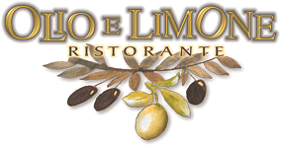
2/10/2012
Innovative Italian Cuisine

Olio e Limone Ristorante (“Oil and Lemon” in Italian).
When husband-wife team Alberto and Elaine Morello opened Olio e Limone Ristorante in November, 1999, their goal was simple - rely on the integrity of the ingredients and the quality of the preparation to offer Santa Barbara creative, authentic Italian cuisine served in an inviting atmosphere.

Chef Alberto Morello, a native of Sicily, grew up with a passion for cooking and began working in restaurants at an early age. At 18, he left Sicily to cook at the Excelsior Hotel in Florence. He then went to Cambridge to learn English and broaden his culinary repertoire. Next he came to California and met Elaine Andersen (a U.C.S.B. alumna and former Santa Barbara resident) at Celestino Ristorante in Beverly Hills, where they both worked and further honed their restaurant skills. Next stop for the couple was Orange County, where Alberto was Executive Chef at Prego Ristorante, Irvine, for eight years while Elaine focused on event planning, catering, fundraising and financial reporting for Prego’s parent company, Spectrum Foods, Inc. Settled in Santa Barbara since 1999, the Morello’s are raising a talented thirteen-year-old son and are the proud owners of two thriving restaurants.They were excited to announce the opening of their casual concept in Summer 2010—Santa Barbara’s original authentic, artisanal Italian pizzeria-enoteca “Olio Pizzeria”—in the space they recently renovated next door.

Olio e Limone is a place where each guest is a “V.I.P.”, where European hospitality and reverence for quality food and convivial dining reign supreme. The menu features dishes from all over Italy, but you’ll also be treated to some touches of Sicily. Be sure to try one of their fabulous quail dishes; Quaglie in Insalata (marinated, grilled quail over mixed greens, walnuts and gorgonzola cheese), Pappardelle al Sugo di Quaglie e Funghi (wide ribbon pasta with quail, sausage and mushroom ragù). You will be transported. The delicate antipasto Timballo di Melanzane (eggplant soufflé in a tomato-basil sauce) will delight your senses, as will the Fiorellini di Melanzane (ravioli filled with roasted eggplant and goat cheese with fresh tomato sauce). Other signature dishes include Fettuccine con Spugnole e Asparagi (ribbon pasta, morel mushrooms and asparagus with cream) and Pesce Spada con Caponata (breaded swordfish with Sicilian ratatouille). You’ll also be pleasantly surprised by the Morello’s award-winning wine list, featuring an extensive selection of Italian and local wines. Their glass-enclosed wine cellar is the focal point of the dining room.
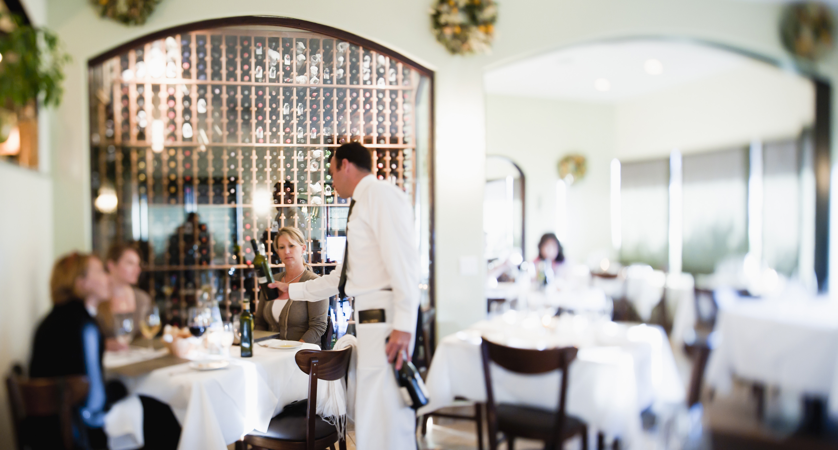

Accolades and selected press excerpts:

Recipient of the coveted Wine Spectator Award of Excellence since 2002.

“Rich, earthy Sicilian dishes crafted from the “freshest” ingredients are supported by a “superb” wine list at this “top-notch” Santa Barbara Italian set in exceedingly “pleasant” – if “tiny” – quarters…a “favorite” in the area.”
~ ZAGAT Survey 2012 and 2011 - Food Rating: 27

“Simply delightful…strong kitchen turns out earthy dishes that show a deft handling of ingredients; husband-and-wife team Alberto and Elaine Morello preside over the lovely ivory-walled dining room giving the operation a personal touch.” ~ ZAGAT Survey 2009

“Husband-wife team Alberto and Elaine Morello pay exquisite attention to detail at this Santa Barbara escape offering fresh pastas, lightly prepared fish and rustic meats among other Italian dishes; most call the service tops and the dining room (with a visible wine cellar) polished, though it is small and fills up quickly.”
~ ZAGAT Survey 2008 - Food Rating: 27

“Interesting menu of very fine food, beautifully presented, including real Sicilian dishes prepared with a deft touch. Excellent cooking and hospitable service.” ~ ZAGAT Survey

“Pan-Italian charmer where each “delish” dish is “made with love”; those excited that the menu is not the same old, same old say, “where else can you find Sardinian malloreddus (a small, ear-shaped pasta)?”
~ ZAGAT Survey

“Simply sophisticated.”
“Best dishes: warm seafood salad, grilled quail salad, carpaccio of pear salad, spaghetti with bottarga, fettuccine with asparagus and morels, pappardelle with a ragù of quail, sausage and mushrooms, veal scaloppine with artichokes, pear tart.” ~ S. Irene Virbila, Los Angeles Times Magazine

Carpaccio of pear salad chosen as one of “L.A.’s Best Dishes from A to Z”.
~ S. Irene Virbila, Los Angeles Times Magazine

“Best Italian restaurant in Santa Barbara County.” ~ The Montecito Journal

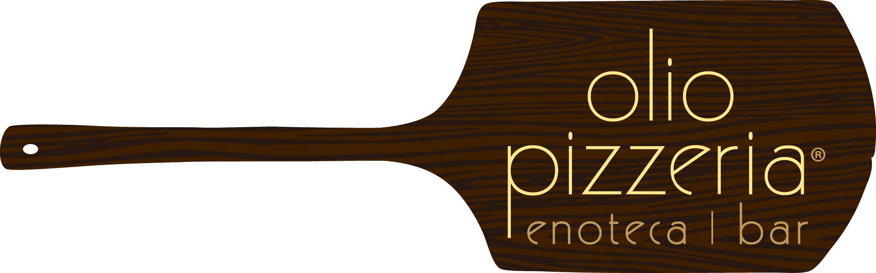

pizza bar | salumi bar | wine bar | full bar
Santa Barbara’s Original Artisanal Pizzeria-Salumeria

Olio Pizzeria, our simple pizza bar-wine bar-full bar casual concept, was inspired by the myriad neighborhood pizzerie and enoteche (wine bars) found around the corner from just about every piazza in italy. This idea began to take shape before we even opened Olio e Limone Ristorante, our fine dining restaurant next door. In contrast, we wanted to create a casual place with an emphasis on simple, delicious everyday artisanal Italian food served in a convivial casual environment, drawing inspiration from all of Italy’s regions, just like we’ve always done at Olio e Limone on a more fine dining, or Ristorante, scale.

Wine bars serving boutique salumi and formaggi are all the rage in Italy right now, as is a new regionalism which we are excited to share with you. Sicily is an emerging powerhouse, and we have always shared touches of Sicilian food and wine with our guests. You will also find exciting tastes from Campania and other emerging regions on our menus and wine lists.

Our pizza is authentically thin, crisp around the edges and moist in the centre, just the way it’s done in Italia. Italians eat their pizza with a fork and knife in

order to fully enjoy the chew of the dough and the melding of ingredients. This is not a requirement, though - just fold the tip inward, and eating a slice with your hands is a cinch!

We are excited to share with you this explosion of boutique ingredients and awareness of regional Italian food and authentic pizza.

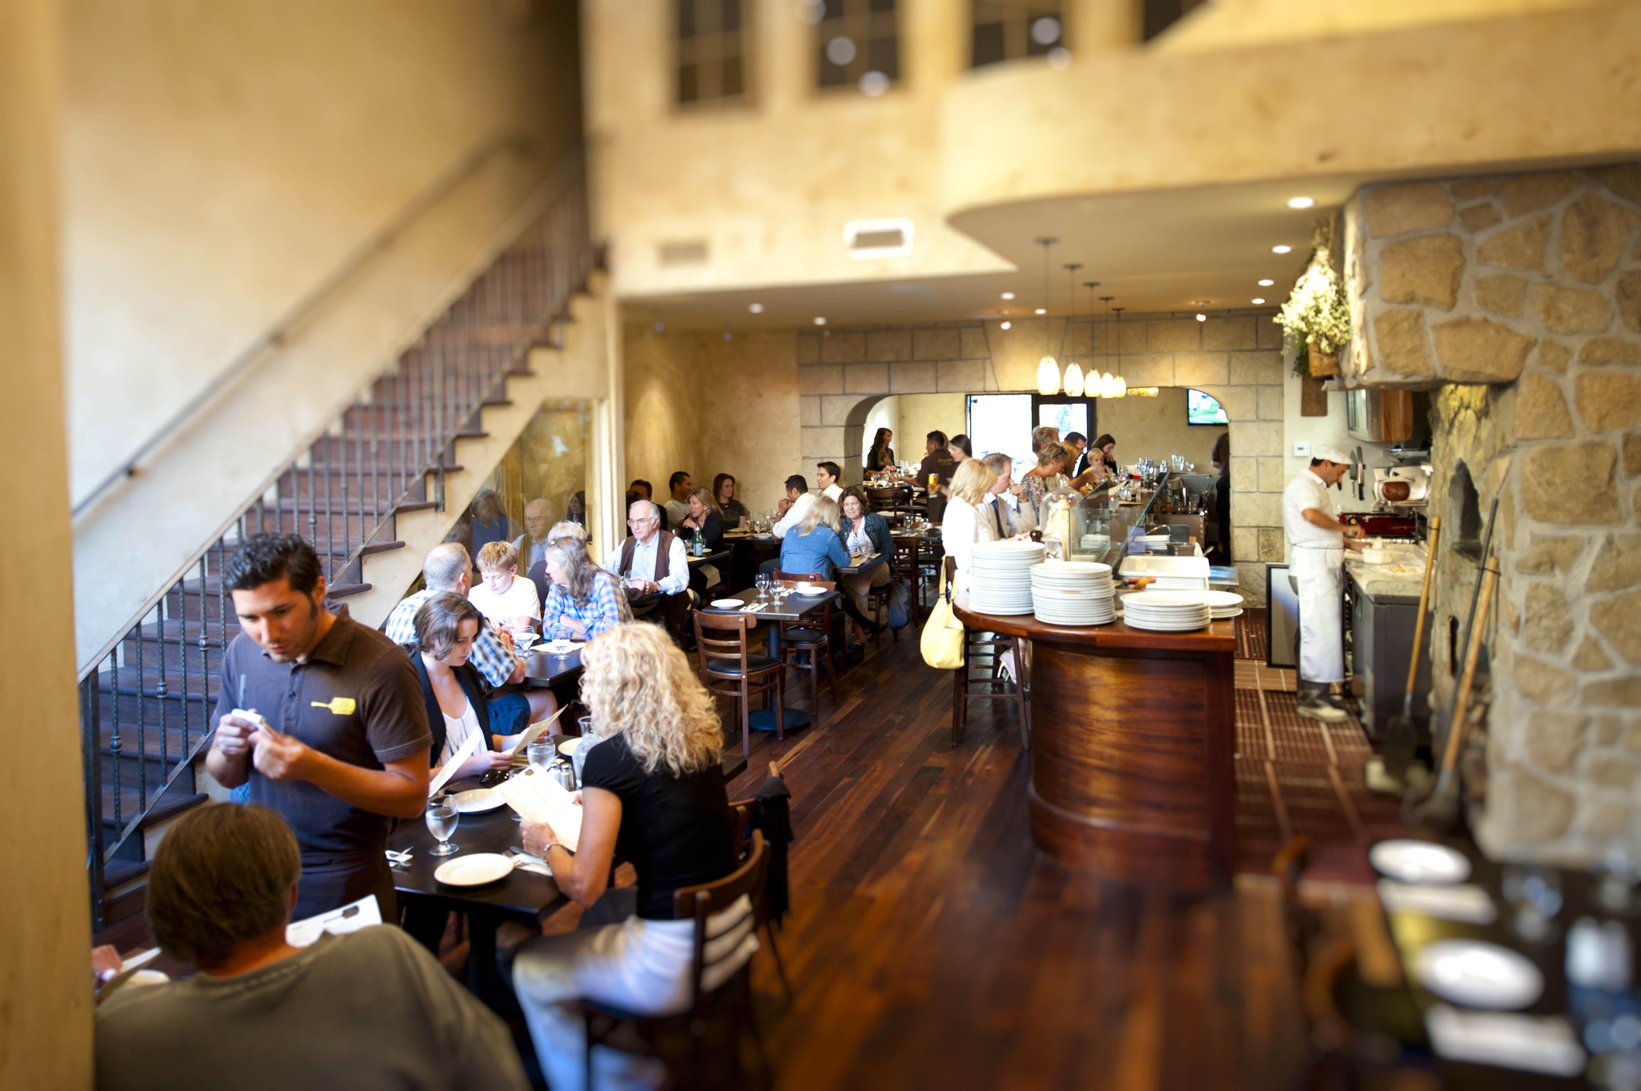

Some Press Links

The Santa Barbara Independent: The 2011 Foodies ; Winner of Best Adult Pizza Night Award
http://www.independent.com/news/2011/sep/29/2011-foodies/#commenttoggle

http://www.sandiegomagazine.com/media/San-Diego-Magazine/July-2011/Santa-Barbara-Eats/
3. For Pizza People:Olio Pizzeria Enoteca and Bar
Chewy, charred, and topped with everything from black truffles to fennel sausage, the pizzas at Olio Pizzeria evoke memories of trips to Italy. Tucked next door to their sister fine dining establishment, Olio e Limone Ristorante, the more casual pizzeria offers an array of small plates from formaggio to octopus salad. Dive into pizzas like the Rianella dressed with tomatoes, fresh mozzarella, pecorino cheese, anchovies, Sicilian oregano, and extra virgin olive oil. The honed wine list is Italian and California focused, so finding a food-friendly Sangiovese is simple. 11 W. Victoria Street, 805-899-2699. oliopizzeria.com

http://www.culturevixen.com/2011/04/olio-pizzeria
04/22/11: Gayle Wheatley
Editor in Chief
Culture Vixen Magazine
Los Angeles, CA
www.CultureVixen.com
Your Stylish Guide to Art + Travel
Food & Wine, April 2011: http://www.foodandwine.com/articles/wine-country-weekend-santa-barbara

03/2011: Frederick Mintchell. http://www.campuscircle.com/review.cfm?r=12715
Issue link (page 20): http://issuu.com/campuscircle/docs/vol21issue10

01/2011 SantaBarbara.com’s Best of 2011: http://www.santabarbara.com/dining/best_of_sb/

10/12/10 SB Independent: http://www.independent.com/news/2010/oct/12/olio-pizzeria/

News-Press article (Life Section, front & back pages): http://oliopizzeria.com/new/press/

Edhat 09/18/10 (Ms. Lemonjelly): http://www.edhat.com/site/tidbit.cfm?nid=39144

07/29/10; Shannon Turner Brooks: http://www.santabarbaraca.com/blog/index.cfm/2010/7/29/Olio-Pizzeria-Opens--Love-at-First-Bite/
Also via www.TheSBPost.com

http://losangeles.grubstreet.com/2010/04/olio_e_limone_opening_olio_piz.html

Chef/Proprietor: Alberto Morello General Manager/Proprietor: Elaine Andersen Morello

11 West Victoria Street, Suites 17/21 | Santa Barbara, CA 93101 | 805.899.2699 P | 866.615.3102 F
olioelimone.com | oliopizzeria.com
ZAGAT-Rated | Wine Spectator Award of Excellence since 2002 | COCKTAILS and SPIRITS
PIZZA BAR-SALUMI BAR-WINE BAR-FULL BAR
Lunch: Mon-Sat, 11:30-2:00 | Dinner: 7 Nights from 5:00
PRIVATE DINING: For up to 40 guests in the CUCINA ROOM at Olio e Limone |For up to 22 guests in the TERRAZZA ROOM
and up to 32 guests in the TAVERNA ROOM at Olio Pizzeria

